**Sequence Diagram: User Data Management**

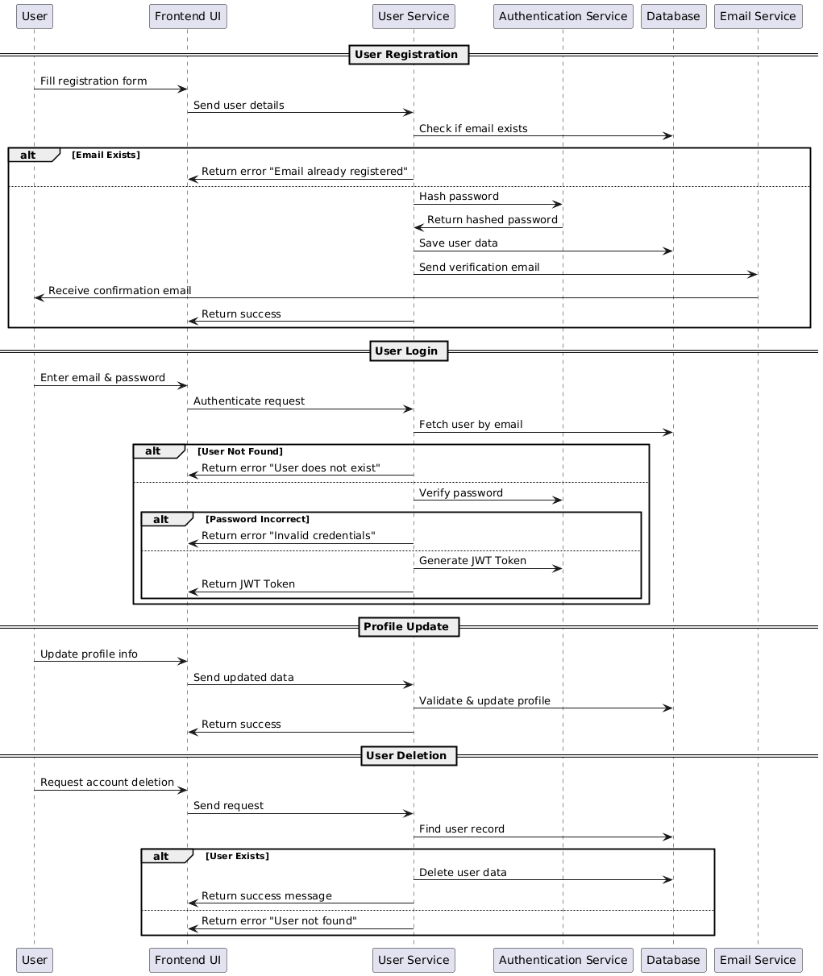

**Database**

**Functional Requirements (FRs)**

**User Registration**

* **FR1:** The system shall allow users to register with a valid email and password.
* **FR2:** The backend API shall validate the provided registration details before creating a user account.
* **FR3:** The backend API shall return an error response if the email is already registered.
* **FR4:** The frontend shall display appropriate success or error messages after registration.

**User Login**

* **FR5:** The system shall allow users to log in using their registered email and password.
* **FR6:** The backend API shall validate user credentials before granting access.
* **FR7:** The frontend shall display an error message if login credentials are incorrect.

**Profile Management**

* **FR8:** The system shall allow users to update their profile details (name, email, contact, etc.).
* **FR9:** The backend API shall validate the provided data before updating the profile.
* **FR10:** The system shall ensure only authorized users can modify their profile details.

**Password Management**

* **FR11:** The system shall allow users to reset their password via email verification.
* **FR12:** The frontend shall display appropriate messages for successful and failed password reset attempts.

**User Deletion**

* **FR13:** The system shall allow users to request account deletion.

**Role-Based Access Control (RBAC)**

* **FR14:** The system shall assign roles (admin, user) to each user account.
* **FR15:** Admin users shall have permission to manage other user accounts.

**Logging & Monitoring**

* **FR16:** The system shall log user actions such as login, profile updates, and password changes.
* **FR17:** Admin users shall have access to user activity logs for security monitoring.

**Non-Functional Requirements (NFRs)**

**Performance & Reliability**

* **NFR1:** The system shall process user registration and login requests within 2 seconds.
* **NFR2:** The system shall handle 1,000+ concurrent user requests without performance degradation.

**Security**

* **NFR3:** The system shall prevent unauthorized access by enforcing role-based access control (RBAC).

**Usability**

* **NFR4:** The user interface shall provide clear and user-friendly error messages.
* **NFR5:** The profile management and login pages shall be responsive and work on both desktop and mobile devices.